Giadinhtiendung e-commerce website

**Use-Case Specification**

**Version** 0.2

**Revision History**

| **Date** | **Version** | **Description** | **Author** |
| --- | --- | --- | --- |
| 14/11/2023 | 0.1 | Initial writings | Lê Quang Trường |
| 16/11/2023 | 0.1 | Gather all use case specification into this document | Nguyễn Văn Tuấn Kiệt |
| 16/11/2023 | 0.1 | Gather all use case specification into this document | Nguyễn Gia Khánh |
| 16/11/2023 | 0.1 | Gather all use case specification into this document | Trần Ngọc Trường Thịnh |
| 16/11/2023 | 0.1 | Gather all use case specification into this document | Bùi Nguyên Hanh |
| 28/11/2023 | 0.2 | Directs the revision meeting and review changes. | Lê Quang Trường |
| 28/11/2023 | 0.2 | Add some use case for vendors. | Nguyễn Văn Tuấn Kiệt |
| 28/11/2023 | 0.2 | Add some use case for vendors. | Nguyễn Gia Khánh |
| 28/11/2023 | 0.2 | Add some use case for vendors. | Trần Ngọc Trường Thịnh |
| 28/11/2023 | 0.2 | Re-edit use case diagram. | Bùi Nguyên Hanh |

**Table of Contents**

1. Use-case model 4

2. Use-case specification 4

2.1. Use-case: User log-in 5

2.2. Use case: Register 5

2.3. Use-case: User log-out 5

2.4. Use-case: Ban users 6

2.5. Use-case: View orders 7

2.6. Use-case: Verify products 8

2.7. Use case: View on sale products 8

2.8. Use case: Search 8

2.9. Use case: Add product to cart 9

2.10. Use case: View cart 10

2.11. Use case: Checkout 11

2.12. Use case: Payment 12

2.13. Use-Case: Add product to favorite 13

2.14. Use-Case: Review product 13

2.15. Use-case: Add product for sale 14

2.16. Use-case: View Statistics15

# Use-case model

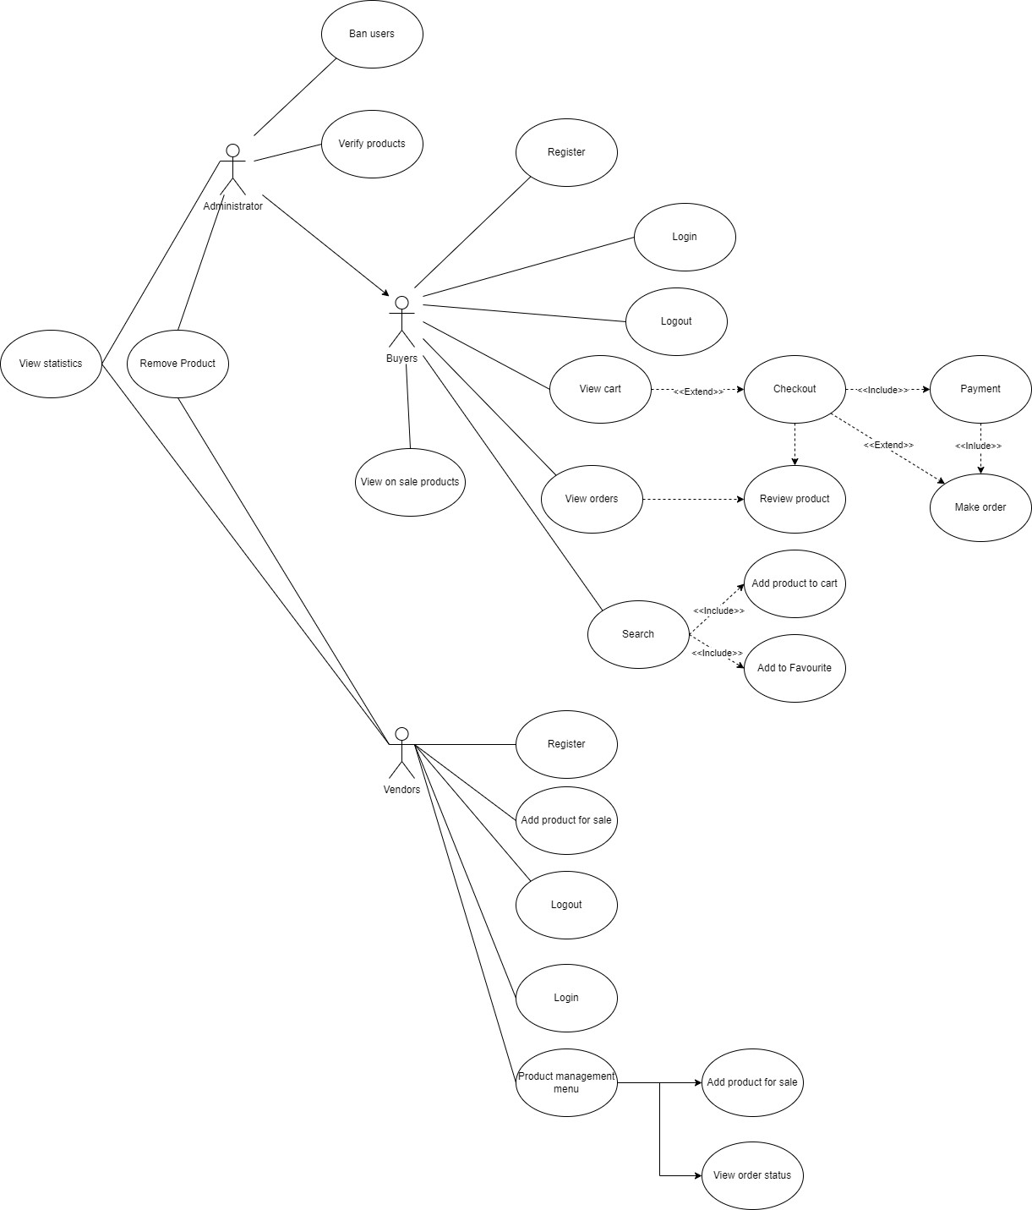

# Use-case specification

# Use-case: User log-in

| Use-case name | Login |
| --- | --- |
| Brief description | This use case covers the process of a registered user (Buyer, Seller, or Admin) logging into the website. The user enters their registered email and password, and upon successful validation, gains access to their respective dashboard. If the credentials are invalid, an error message is displayed. |
| Actors | Guest |
| Basic Flow | 1. User enters registered email and password 2. System validates credentials. 3. If credentials are valid, the system logs in the user. 4. Users gain access to their respective dashboard. |
| Alternative flow | Alternative flow 1: Invalid credentials   1. An error message is displayed 2. The user is prompted to re-enter. 3. Back to step 1 |
| Pre-conditions | 1. User has a registered account. 2. User can access to the page |
| Post-conditions | 1. User is logged in the system |

## 

# Use case: Register

| Use-case name | Register |
| --- | --- |
| Brief description | The user provides necessary information, and upon successful validation, a new account is created. A confirmation email is sent to the user, who activates their account by clicking on the confirmation link. |
| Actors | Guest |
| Basic Flow | 1. User provides required information (name, email, password). 2. System validates information. 3. If validation is successful, the system creates a new user account. 4. Confirmation email is sent. 5. User clicks the confirmation link to activate the account. |
| Alternative flow | Alternative flow 1: email already exists   1. Prompt a message 2. Return to step 1   Alternative flow 2: invalid password format   1. Highlight the password input field 2. Return to step 1 |
| Pre-conditions | User can access to the landing page |
| Post-conditions | The user successfully created a new account |

# Use-case: User log-out

| Use-case name | Log out |
| --- | --- |
| Brief description | The user select sign out button to exit the account, if a payment still in process, notify the user before logout. Upon successful log out, the user is redirected to the landing page. |
| Actors | User |
| Basic Flow | 1. User select the log out button 2. System checks for any order in process 3. System log out, redirect user to the landing page 4. Users gain access to their respective dashboard. |
| Alternative flow | Alternative flow 1: Orders in process   1. Prompt a dialog, notify the user 2. Continue to step 3 |
| Pre-conditions | 1. User has already logged in |
| Post-conditions | 1. User is logged out the system |

# Use-case: Ban users

| Use-case name | Ban users |
| --- | --- |
| Brief description | 1. This use case describes the process in which an administrator bans a user/vendor |
| Actors | User |
| Basic Flow | 1. The administrator navigates to the user management section in the admin panel. 2. The administrator selects the user they wish to ban. 3. The administrator chooses the "Ban User" option from the user management interface. 4. The system prompts the administrator to provide a brief reason for banning the user. 5. The administrator confirms the ban action. 6. The system executes the ban, restricting the banned user's access to the website. 7. If configured, the system sends a notification to the banned user, informing them of the ban and providing the reason. |
| Alternative flow | At any step before confirming the ban, the administrator can choose to cancel the ban action, returning to the user management interface without banning the selected user. |
| Pre-conditions | 1. The administrator is logged into the admin panel. 2. The administrator has the necessary permissions to perform user banning. |
| Post-conditions | 1. The banned user is denied access to the e-commerce website. 2. The ban action is logged in the system for auditing purposes. |

## 

# Use-case: View orders

| Use-case name | View orders |
| --- | --- |
| Brief description | This use case outlines the steps for a buyer to view the status and details of their orders after making a purchase on the online shop |
| Actors | User |
| Basic Flow | 1. The buyer navigates to the order history section on the online shop 2. The system displays a list of the buyer's past orders, organized chronologically 3. The buyer selects a specific order from the list to view its details 4. The system presents detailed information about the selected order 5. The buyer can view the availability status of each product in the order 6. If applicable, the buyer can check the current shipping status of the order 7. The system displays the current status of the order |
| Alternative flow | Alternative flow 1: No orders   1. Prompt a dialog, notify the buyer |
| Pre-conditions | 1. The buyer is logged into their account on the e-commerce website 2. The buyer has completed at least one purchase transaction |
| Post-conditions | The buyer has successfully viewed the details and status of the selected order |

## 

# Use-case: Verify products

| Use-case name | Login |
| --- | --- |
| Brief description | This use case outlines the steps for the administrator to review and verify a product submitted by a vendor before it can be listed for sale on the e-commerce website. |
| Actors | Admin |
| Basic Flow | 1. The administrator navigates to the product verification section in the admin panel. 2. The system displays a list of pending product requests from vendors awaiting verification. 3. The administrator selects a specific product request from the list to review. 4. The system presents the administrator with detailed information about the product, including images, description, pricing, and any other relevant details provided by the vendor. 5. The administrator decides whether to confirm or deny the product. 6. If the product is denied, the administrator may provide feedback to the vendor explaining the reason for denial. |
| Alternative flow | Alternative flow 1: At any step before confirming or denying the product, the administrator can choose to cancel the verification process, returning to the list of pending product requests. |
| Pre-conditions | 1. The administrator is logged into the admin panel. 2. The vendor has submitted a request to sell a product. 3. The vendor has provided all necessary information about the product. |
| Post-conditions | 1. If confirmed, the product is listed on the e-commerce website. 2. If denied, the product is not listed, and the vendor is informed of the denial. |

## 

# Use case: View on sale products

| Use-case name | View on sale products |
| --- | --- |
| Brief description | This use case illustrates how users can view products available for sale on the website. |
| Actors | Buyers and Vendors |
| Basic Flow | 1. Users access the homepage or product catalog section of the furniture e-commerce website. 2. The system displays a list/grid view of available products categorized as 'on sale.' 3. Users browse through the list of on-sale products, viewing their titles, images, descriptions, and discounted prices (if applicable). 4. Users can click on a specific product to view its detailed information. |
| Alternative flow | * If there are no products listed under the 'on sale' category: The system displays a message indicating the absence of currently discounted products but still shows regular-priced items. * If the user encounters technical issues while accessing the on-sale products: The system shows an error message and suggests refreshing the page or contacting support. |
| Pre-conditions | The website is accessible and functional. |
| Post-conditions | Users have successfully viewed the available on-sale products and can proceed to explore further details or make a purchase. |

# Use case: Search

| Use-case name | Search |
| --- | --- |
| Brief description | This use case describes how the User can view search products |
| Actors | Buyers and Vendors |
| Basic Flow | 1. At the homepage, the user enters keywords on the search field 2. Users clicks on ‘Search’ button to start searching a product 3. System will display the products found |
| Alternative flow | - User cannot find products searched:   * User search stuffs on searching bar * There’s no product searched exist in shop so the result return is ‘Not Found’ |
| Pre-conditions | User goes to homepage at https://giadinhtiendung.vn |
| Post-conditions | The user successfully retrieve the products found |

# Use case: Add product to cart

| Use-case name | Add product to cart |
| --- | --- |
| Brief description | When shopping, user have a cart to add their interested products then at the end, they may remove some, make their final decision and proceed to the payment page. |
| Actors | Buyers |
| Basic Flow | 1. User view a product and click the add to cart button. 2. If the cart is not already created, create a cart and add the product that user is selecting to the cart. |
| Alternative flow | 1. User click “Add to cart” button on the thumbnail of the product that is listed on the searching page. 2. If the cart is not already created, create a cart and add the product that user is selecting to the cart. |
| Pre-conditions | 1. There is no cart in the session 2. There is a cart in the session |
| Post-conditions | 1. A cart is created with products in it 2. The number of product is increased |

# Use case: View cart

| Use-case name | View cart |
| --- | --- |
| Brief description | User can have a cart while shopping on the website to see what they selected. |
| Actors | Buyers |
| Basic Flow | 1. User clicks on the the “Cart” button    1. The website load all products that user selected and display them    2. User click “Purchase” button on the view cart page to proceed to payment page |
| Alternative flow | 1. User increase or decrease the amount of product in the carts    1. User clicks on the the “Cart” button    2. The website load all products that user selected and display them    3. User click on “+” or “-” buttons beside every products    4. The website increases/decreased the number of according product. 2. User remove a product from the cart    1. User clicks on the the “Cart” button    2. The website load all products that user selected and display them    3. User clicks on “Remove” button aside of a product    4. The website remove the according product from the cart 3. There is no cart created already    1. User clicks on the the “Cart” button    2. The website send a notification say that there is nothing in the cart    3. User continue shopping 4. User exit the view cart page and continue shopping    1. User clicks on the the “Cart” button    2. The website load all products that user selected and display them    3. User clicks “Back” button on the screen corner or “Back” button of the browser    4. The website return to the page that user has previously been before |
| Pre-conditions | 1. The website is displaying searching page 2. The website is displaying a product page |
| Post-conditions | 1. The website displays the cart page 2. The website displays the cart page is increased, decreased amount of products. 3. The website displays a notification to tell user to add some product to the cart |

# Use case: Checkout

| Use-case name | Checkout |
| --- | --- |
| Brief description | After adding products to cart, user may proceed to checkout page, fill out informations for payment and delivery. The website will display total cost plus delivery cost to the user. |
| Actors | Buyers |
| Basic Flow | 1. User proceed to checkout page 2. The website displays products that have been chosen and calculate their total price and delivery cost. 3. User fill out delivery information, chose payment method then proceed to payment page by clicking “Purchase” button. |
| Alternative flow | 1. User increase or decrease the amount of product in the carts    1. User may increase or decrease the amount of certain product to be purchased    2. The website update their total price and delivery cost 2. User choose cash payment method    1. User choose cash payment method and clicks purchase button    2. The website goes directly to order page showing their order with delivery information 3. User exit the checkout page and continue shopping    1. User clicks “Back” button while in checkout page    2. The website return to view cart page |
| Pre-conditions | 1. The website is displaying view cart page 2. The website is displaying a payment page |
| Post-conditions | 1. The website displays the checkout page 2. The website displays the checkout page with increased, decreased amount of products. 3. The website returns to the view cart page 4. The website proceeds to payment page 5. The website proceeds to view order page |

# Use case: Payment

| Use-case name | Payment |
| --- | --- |
| Brief description | After completing checkout phase, if user chooses credit card method, the website proceed to payment page. User may now fill out credit card information and make their order. |
| Actors | Buyers |
| Basic Flow | 1. User proceeds to payment page 2. Website display forms to enter credit card information 3. User fill out forms 4. Website checks validity then proceed to payment service provider if successful. 5. User confirm their payment 6. Website makes the order and proceeds to view the created order |
| Alternative flow | 1. User’s credit card information is invalid    1. User enter credit card information    2. The website check the validity and found them invalid.    3. A notification pops up requesting the user to check their credit card information 2. User didn’t confirm their payment to the payment service provider    1. Website checks validity then proceed to payment service provider if successful.    2. The user cancel the confirmation    3. Website return to payment page 3. User exit the payment page    1. User clicks “Back” button while in payment page    2. The website return to checkout page |
| Pre-conditions | The website is displaying checkout page |
| Post-conditions | 1. The website displays the checkout page 2. The website displays the payment page with notification 3. The website proceeds to view order page |

# Use-Case: Add product to favorite

| Use-case name | Add product to favorite |
| --- | --- |
| Brief description | When searching for products, users want to save products that they like but can’t afford immediately. So they will add these products to favorite |
| Actors | Buyers |
| Basic Flow | 1. User view a product and click the add to favorite. 2. Create a favorite list and add the product that user is selecting to the favorite section. |
| Alternative flow | 1. User click “Add to favorite” button on the thumbnail of the product that is listed on the searching page. 2. If the favorite list is not already created, create a list and add the product that user is selecting to the favorite list |
| Pre-conditions | 1. There is no list in the session 2. There is a list in the session |
| Post-conditions | 1. A list is created with products in it 2. The number of product is increased |

# Use-Case: Review product

| Use-case name | Review product |
| --- | --- |
| Brief description | This use case outlines the steps for a buyer to review a product they have purchased from a vendor on online shop |
| Actors | Buyers |
| Basic Flow | 1. The buyer navigates to their order history section on the e-commerce website 2. The buyer selects the specific order containing the product they want to review 3. The system provides an option for the buyer to review the product associated with the selected order. The buyer write review, rate product and then submit |
| Alternative flow | 1. The buyer may have the option to edit their review after submission if they wish to make changes or add more details 2. The buyer may have the option to delete their review if they change their mind or encounter issues with the product after the initial review |
| Pre-conditions | 1. The user is logged into their account on the e-commerce website 2. The user successfully completed a purchase transaction. 3. The user has received the product |
| Post-conditions | 1. The product review is recorded and associated with the specific order and product 2. The review is made visible on the product page for other potential buyers to see |

# Use-case: Add product for sale

| Use-case name | Add product for sale |
| --- | --- |
| Brief description | This use case outlines the process of adding a product for sale on the website. |
| Actors | Vendors |
| Basic Flow | 1. The vendor selects the option to add a new product for sale. 2. The system prompts the vendor to enter details about the new product, including: Product name, Product description, Category and subcategory, Pricing (e.g., regular price, sale price), Quantity available, Product images 3. If the product has variations (e.g., sizes, colors), the vendor has the option to specify them along with their respective prices and quantities. 4. Set Shipping Information: 5. The vendor provides shipping details, including the weight of the product, shipping method options, and any associated shipping costs. 6. The vendor sets the availability status of the product, indicating whether it is in stock and ready for sale. 7. The vendor submits the product information to the system for review and approval before it is made live on the e-commerce platform. |
| Alternative flow | 1. If required fields are incomplete or contain invalid data: The system prompts the vendor to provide valid information and doesn't proceed until correct details are entered. 2. If the product already exists in the system: The system alerts the vendor and prevents duplication. 3. If the vendor encounters technical issues during the submission: The system displays an error message and advises the vendor to try again or contact technical support. |
| Pre-conditions | The vendor has logged into the website's admin system. |
| Post-conditions | The new product is successfully added to the website's product catalog and is available for customers to view and purchase. |

# Use-case: View Statistics

| Use-case name | View Statistics |
| --- | --- |
| Brief description | The user accesses a dedicated section within the system to view statistical data related to various aspects, such as user activity, sales performance, website traffic, or any other relevant metrics. The statistics are presented in a comprehensive and understandable format, aiding the user in making informed decisions or gaining insights. |
| Actors | Vendors. Administrator |
| Basic Flow | 1. User navigates to the "Statistics" or relevant section within the system. 2. System displays an overview of available statistical categories or metrics. 3. User selects a specific category or metric to view detailed statistics. 4. System retrieves and presents the relevant statistical data in graphical, tabular, or descriptive formats. 5. User analyzes the statistics to gain insights or make informed decisions.   User may further customize the view or apply filters to refine the displayed statistics.  User exits the statistics section when done. |
| Alternative flow | 1. User is logged into the system. 2. The system is operational and capable of retrieving statistical data.The system is operational and capable of retrieving statistical data. |
| Pre-conditions | 1. User is logged into the system. 2. The system is operational and capable of retrieving statistical data. |
| Post-conditions | 1. User gains insights or makes decisions based on the viewed statistics. 2. User exits the statistics section and continues using the system as required. |

* 1. **Product management menu**

| Use-case name | Product management menu |
| --- | --- |
| Brief description | Vendors could have a general view about their business in the product management menu. |
| Actors | Vendors |
| Basic Flow | 1. The vendor select “Product management” 2. The system show the product management menu showing information about their products, orders and brief status. |
| Alternative flow | 1. User is logged into the system. 2. The system is operational and capable of retrieving statistical data.The system is operational and capable of retrieving statistical data. |
| Pre-conditions | 1. User is logged into the system. 2. The system is operational and capable of retrieving statistical data. |
| Post-conditions | 1. User gains insights or makes decisions based on the viewed statistics. 2. User exits the statistics section and continues using the system as required. |

* 1. **Use-case: view order status**

| Use-case name | View Statistics |
| --- | --- |
| Brief description | This use case outlines the steps for a buyer to view the real-time status of their order, which is updated by the vendor on the e-commerce website. |
| Actors | Buyer, Vendor |
| Basic Flow | 1. The buyer navigates to the order history section on the e-commerce website. 2. The system displays a list of the buyer's past orders, organized chronologically. 3. The buyer selects a specific order from the list to view its details. 4. The system presents the real-time status of the selected order, as updated by the vendor. This may include stages such as:Order received, Payment confirmed, Product(s) shipped, Out for delivery, Delivered 5. The buyer can check for any additional updates or comments provided by the vendor regarding the status of individual products within the order. |
| Alternative flow | If the buyer has not completed any purchases, the system notifies the buyer that there are no previous orders to display. |
| Pre-conditions | 1. User is logged into the system. 2. The system is operational and capable of retrieving statistical data. |
| Post-conditions | The buyer has successfully viewed the real-time status of the selected order as updated by the vendor. |